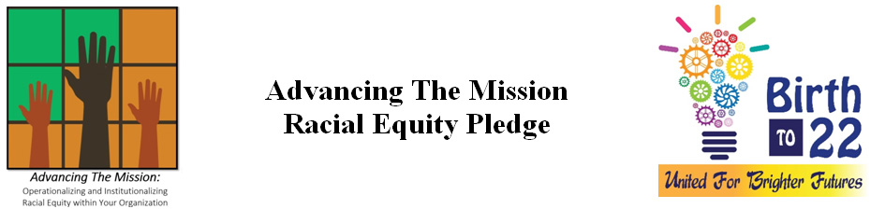
The Advancing The Mission (ATM) Pledge Form is intended for organizations (government, non-profit, for-profit, businesses, or foundation) serving residents in Palm Beach County. Participation is strictly voluntary.

Our organization recognizes that racial inequities currently exist across all indicators for success, including in education, criminal justice, jobs, housing and health, regardless of intent. We understand that institutions have a role to play in addressing this issue. For this reason, we pledge to join the Advancing the Mission movement by normalizing conversations about race within our organization, operationalizing new policies, practices and organizational cultures, and organizing to achieve racial equity. More specifically, we will:
- Educate our employees about systemic racism and the impact on Black lives and People of Color by participating in the Racial Equity Institute, Race to Equity Summits and Groundwater trainings.
- Develop a racial equity statement and organize an internal racial equity core team and send designated representatives to the Advancing the Mission workshops, which are designed to enhance leaders’ ability to operationalize and institutionalize racial equity within their respective organizations.
- Utilize tools shared from the Advancing the Mission website and Government Alliance on Race & Equity (GARE) to assess our organization’s readiness to advance racial equity within our institution’s policies, practices and programs and external to service delivery systems and community engagement functions.
- Work to develop a racial equity action plan to guide the organization’s racial equity work. The plan should clearly outline objectives and specific actions to achieve those objectives and serve as a blueprint for work internal and external to the organization.
- Report our progress on advancing racial equity in an effort to share best practices and measure our collective impact at a community level.
Racial equity will be achieved when we eliminate racial disproportionalities so that race can no longer be used to predict success. Our organization will set goals and track our progress, with the recognition that strategies must be targeted to close the gaps. Systems and structures that are failing communities of color are actually failing all of us, economically and psychologically. For this reason, we believe that advancing racial equity is to our collective benefit.
Advancing the Mission is a learning community and participation in the network and through acceptance of this pledge recognizes that your information can be shared within and external to the PBC learning community. This Pledge Form is a statement of intent only, is not legally binding upon the parties, and implies no financial commitment on the part of any partner member. This Pledge Form is strictly voluntary.
Name:(The pledge is to be signed by Sr. Leadership Team member, capable of making decisions on behalf of the organization.)

